ABSTRACT

1.COLPITTS OCILLATOR WITH CURRENT SHUNT FEEDBACK AMPLIFIER

The need for stable, high-frequency oscillators in electronic systems drives the design of circuits like the Colpitts oscillator, which can generate sinusoidal signals. This project aims to design a Colpitts oscillator operating at 25 kHz and enhance its signal level using a current shunt feedback amplifier for practical applications.

The Colpitts oscillator was designed with an LC network to set the frequency at 25 kHz. A current shunt feedback amplifier was incorporated to provide necessary signal amplification. Component values were selected for optimal performance, and the circuit was simulated and implemented on a breadboard for testing.

The oscillator successfully generated a stable 25 kHz sinusoidal signal, which was amplified using the feedback amplifier. Experimental results, compared with simulations, showed minimal distortion and stable oscillations. Challenges related to component tolerances and biasing were addressed during the design process.

2.IMPLEMENTATION OF NAND GATE USING PN JUNCTION DIODE

The realization of logic gates forms the foundation of digital electronics, with the NAND gate being a universal gate that can construct any other logic gate. Traditional logic gates are implemented using transistors or integrated circuits, but this project explores an alternative approach by designing a NAND gate using PN junction diodes. This approach emphasizes understanding the fundamental principles of digital logic and semiconductor behavior, providing a simplified and cost-effective method for constructing basic logic gates.

The methodology involves arranging PN junction diodes and resistors in a configuration that performs the logical NAND operation. The diodes leverage their unidirectional current flow property to control the output voltage based on the input conditions. When both inputs are high, the diodes conduct, producing a low output. For all other input combinations, the diodes prevent current conduction, resulting in a high output. The circuit design was tested using standard input combinations to validate the behavior against the NAND truth table.

The results confirm that the designed circuit successfully replicates the functionality of a NAND gate, adhering to the expected logic outputs. This implementation demonstrates the viability of using diodes for logic operations and highlights their potential in educational and experimental setups. The simplicity of this design makes it an excellent tool for understanding digital logic at a fundamental level, bridging the gap between theoretical concepts and practical application.
PROBLEM STATEMENT

1.COLPITTS OCILLATOR WITH CURRENT SHUNT FEEDBACK AMPLIFIER
Oscillators are essential in modern electronics for generating stable, high-frequency sinusoidal signals used in communication systems, RF applications, and digital circuits. The Colpitts oscillator is a popular solution due to its simple design and reliable frequency stability. However, generating a signal at a precise frequency with adequate amplitude for practical use remains a challenge.
Historically, Colpitts oscillators have been widely used for RF and clock signal generation, but issues such as frequency drift and low output signal amplitude often hinder their performance. To address these challenges, engineers developed techniques for signal amplification and stabilization over time.
Today, the main challenge is designing oscillators that operate at higher frequencies with minimal distortion and sufficient output levels. A current shunt feedback amplifier is a solution that can enhance the output signal of a Colpitts oscillator, ensuring it is strong enough for practical applications. This project aims to design a Colpitts oscillator at 25 kHz, using the current shunt feedback amplifier to improve the signal amplitude.

2.IMPLEMENTATION OF NAND GATE USING PN JUNCTION DIODE

Digital electronics form the backbone of modern technology, with logic gates serving as the fundamental building blocks for all digital systems. Among these gates, the NAND gate holds special significance as a universal gate, capable of implementing any other logic function. Conventional NAND gates are typically realized using transistors or integrated circuits (ICs). However, such implementations often obscure the foundational principles behind logic gate operations. There is a need for an alternative approach that simplifies the design, reduces component complexity, and enhances the understanding of the basic functioning of logic gates.

The primary challenge lies in constructing a NAND gate using minimal and fundamental electronic components, such as PN junction diodes. Diodes, with their ability to allow current flow in only one direction, present a potential alternative for creating logic gates. However, designing a functional circuit that adheres to the truth table of a NAND gate while maintaining signal reliability and consistency poses significant challenges. These include ensuring proper biasing, managing voltage drops across diodes, and minimizing circuit noise or instability. Additionally, it is essential to design a configuration that works seamlessly with varying input conditions to produce the expected logical output.

This project addresses the problem of implementing a NAND gate using PN junction diodes, focusing on simplicity, functionality, and educational value. By leveraging the inherent properties of diodes, the project aims to create a reliable and efficient logic circuit that aligns with the standard truth table of a NAND gate. The ultimate goal is to bridge the gap between theoretical concepts in digital logic and practical circuit design while emphasizing the role of basic semiconductor devices in logic operations.
MEDOTHLOGY
- COLPITTS OCILLATOR WITH CURRENT SHUNT FEEDBACK AMPLIFIER

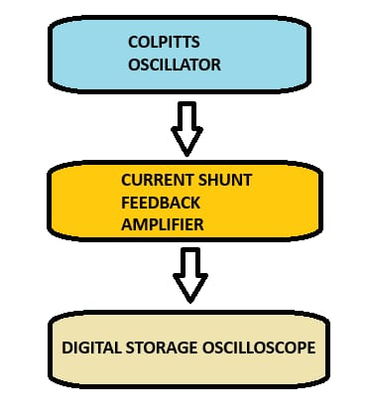
EXPLANATION

The block diagram illustrates the design flow of a system aimed at generating, amplifying, and analyzing a sinusoidal waveform. The process begins with the Colpitts oscillator, which is designed to produce a stable sinusoidal wave at a frequency of 20 kHz. This oscillator utilizes an LC tank circuit and a feedback mechanism to ensure sustained oscillations at the desired frequency. The generated signal, which might have a low amplitude, is then passed to the current shunt feedback amplifier. This stage amplifies the signal to a higher amplitude while maintaining stability, improving linearity, and minimizing distortion through the use of a current shunt feedback network. Amplification is crucial to ensure that the signal can be effectively analyzed or used in subsequent stages.

The amplified sinusoidal signal is then sent to a digital storage oscilloscope (DSO), where it is visualized and analyzed. The DSO captures and displays the waveform, allowing for a detailed examination of its characteristics, such as amplitude, frequency, phase, and any possible distortions. This step ensures that the design and operation of both the oscillator and the amplifier meet the desired specifications. Overall, the system integrates signal generation, amplification, and precise analysis, showcasing the practical implementation of oscillator and amplifier circui ts.
- IMPLEMENTATION OF NAND GATE USING PN JUNCTION DIODE
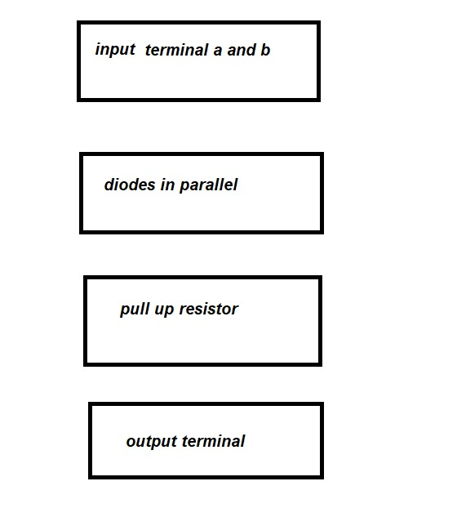

- EXPLANATION

The provided block diagram outlines the key stages in the design and operation of a system intended for generating, amplifying, and analyzing sinusoidal waveforms, specifically focusing on a 20 kHz output frequency. This system integrates an oscillator, amplifier, and a measurement tool to achieve a seamless flow of signal processing and evaluation.

The Colpitts oscillator serves as the foundational stage of the system. It is designed to generate a sinusoidal waveform at the desired frequency, relying on an LC tank circuit comprising inductors and capacitors. This tank circuit determines the oscillation frequency, while a feedback network ensures the oscillations are sustained. The Colpitts design is particularly favored for its simplicity and stability, making it a suitable choice for generating high-frequency signals.

Once the sinusoidal signal is generated, it is routed to the current shunt feedback amplifier for amplification. This stage enhances the amplitude of the signal to ensure it is strong enough for further processing or practical applications. The use of a current shunt feedback mechanism in the amplifier provides better stability and gain control. It also minimizes distortions, preserving the quality of the waveform. The feedback loop ensures that the output remains consistent and reliable, which is critical for accurate analysis.

Finally, the amplified sinusoidal signal is sent to the digital storage oscilloscope (DSO) for visualization and analysis. The DSO plays a crucial role in verifying the performance of the system. It allows for detailed observation of waveform characteristics, such as amplitude, frequency, and potential distortions. By storing and displaying the signal digitally, the DSO provides a clear and accurate representation of the waveform, enabling engineers to validate the system’s functionality.

DESIGN AND IMPLEMENTATION
- COLPITTS OCILLATOR WITH CURRENT SHUNT FEEDBACK AMPLIFIER
- The design of the project revolves around generating a stable sinusoidal wave at 20 kHz and amplifying it to a usable level. This is achieved through a Colpitts oscillator and a current shunt feedback amplifier network, which are integrated to ensure signal quality, frequency stability, and effective amplification. The Colpitts oscillator serves as the core of the signal generation process, leveraging a capacitive divider in its feedback loop to maintain the oscillation frequency and sustain the sinusoidal waveform. The use of a transistor in the oscillator circuit provides the necessary gain to ensure that oscillations are continuous and free from distortion.
- The oscillator design focuses on achieving a stable waveform by implementing proper biasing, which prevents issues such as signal clipping or amplitude attenuation. Additionally, the circuit is designed to be resilient to variations in environmental conditions, such as changes in temperature, ensuring that the frequency remains consistent. This stability is crucial for applications requiring precise and reliable signals.
- The second stage of the design employs a current shunt feedback amplifier to amplify the signal produced by the oscillator. This configuration is chosen for its ability to enhance linearity, reduce distortion, and stabilize the gain of the amplifier. The integration of negative feedback within this stage minimizes noise and ensures the output signal is an accurate representation of the input. This approach guarantees that the amplified signal maintains high fidelity, which is essential for practical applications.
- The implementation begins with theoretical analysis to determine the necessary components and circuit parameters. Simulation tools such as LTspice or Multisim are used to validate the design, allowing the evaluation of the oscillator’s waveform and the amplifier’s performance under ideal conditions. Adjustments to component values are made during this phase to optimize the circuit’s operation. Once the simulation results are satisfactory, the circuit is prototyped on a breadboard to identify and address practical challenges, such as noise interference or unexpected variations in component behavior. After fine-tuning, the circuit is transferred to a printed circuit board (PCB) for greater stability and durability.
- Testing and validation are integral to the implementation process. The sinusoidal output of the oscillator is monitored using an oscilloscope to confirm it meets the target frequency and amplitude. The amplifier is also tested to ensure it provides the desired gain while maintaining signal fidelity and reducing distortion. Feedback networks are adjusted as necessary to optimize performance, ensuring the system operates reliably in various conditions. Stress tests are conducted to evaluate the circuit’s stability under fluctuations in power supply and environmental factors, confirming its robustness.
- The overall design is characterized by its focus on stability, efficiency, and adaptability. By combining the reliable performance of the Colpitts oscillator with the precision and noise reduction of the current shunt feedback amplifier, the project achieves a practical solution for generating and amplifying sinusoidal waves. This modular and versatile design can be adapted for use in signal processing, communication systems, and testing equipment, demonstrating its wide applicability and effectiveness.

- IMPLEMENTATION OF NAND GATE USING PN JUNCTION DIODE

- The design of a NAND gate using PN junction diodes focuses on leveraging the diodes' unidirectional current flow properties to achieve logical operations. The NAND gate, a fundamental building block of digital electronics, outputs a LOW signal only when both inputs are HIGH; otherwise, the output remains HIGH. This behavior is replicated in a simple circuit using PN junction diodes, resistors, and a power source.
- The circuit design involves two diodes connected in parallel with their anodes connected to the input terminals and their cathodes joined together at a single node. This node is connected to the output terminal through a resistor. A pull-up resistor links the output terminal to the power supply, ensuring the output defaults to a HIGH state when no diodes are conducting.
- When both inputs are HIGH, both diodes conduct, creating a low-resistance path to ground. This causes the output to drop to a LOW state, satisfying the NAND gate's truth table. For any other input combination, at least one diode is reverse-biased, preventing current flow to ground. This ensures the output remains HIGH, maintained by the pull-up resistor.
- The methodology involves theoretical analysis followed by practical implementation. Theoretical analysis is performed to determine the appropriate values for the resistors and to ensure the diodes operate within their specified parameters. Circuit simulation tools like LTspice are used to validate the design. These simulations help identify and correct potential issues, ensuring the circuit functions as a NAND gate.

- Once validated, the circuit is prototyped on a breadboard to test its performance under real-world conditions. Standard input combinations (00, 01, 10, 11) are applied, and the output is observed using a multimeter or oscilloscope. The output is compared to the expected results in the NAND truth table to confirm proper functionality.
- Component selection plays a critical role in ensuring the success of this implementation. Low forward-voltage-drop diodes are chosen to minimize power losses and enhance circuit reliability. Resistor values are carefully selected to balance current flow and maintain logic voltage levels. Additionally, a pull-up resistor is used to ensure the output remains at a stable HIGH state when no current flows through the diodes.
- Challenges encountered during the design process include managing the voltage drop across the diodes and ensuring the output voltage levels adhere to logic thresholds. Proper circuit layout and grounding techniques are employed to minimize noise and prevent unintended conduction paths, ensuring consistent and accurate operation. Testing under varying conditions further validates the design's robustness and adaptability.
- The final implementation demonstrates that a NAND gate can be effectively constructed using PN junction diodes. This design is simple yet functional, providing a clear understanding of how digital logic gates can be built with basic electronic components. It serves as a practical educational tool and a foundation for exploring more advanced digital logic
RESULTS AND DISCUSSION
1.COLPITTS OCILLATOR WITH CURRENT SHUNT FEEDBACK AMPLIFIER

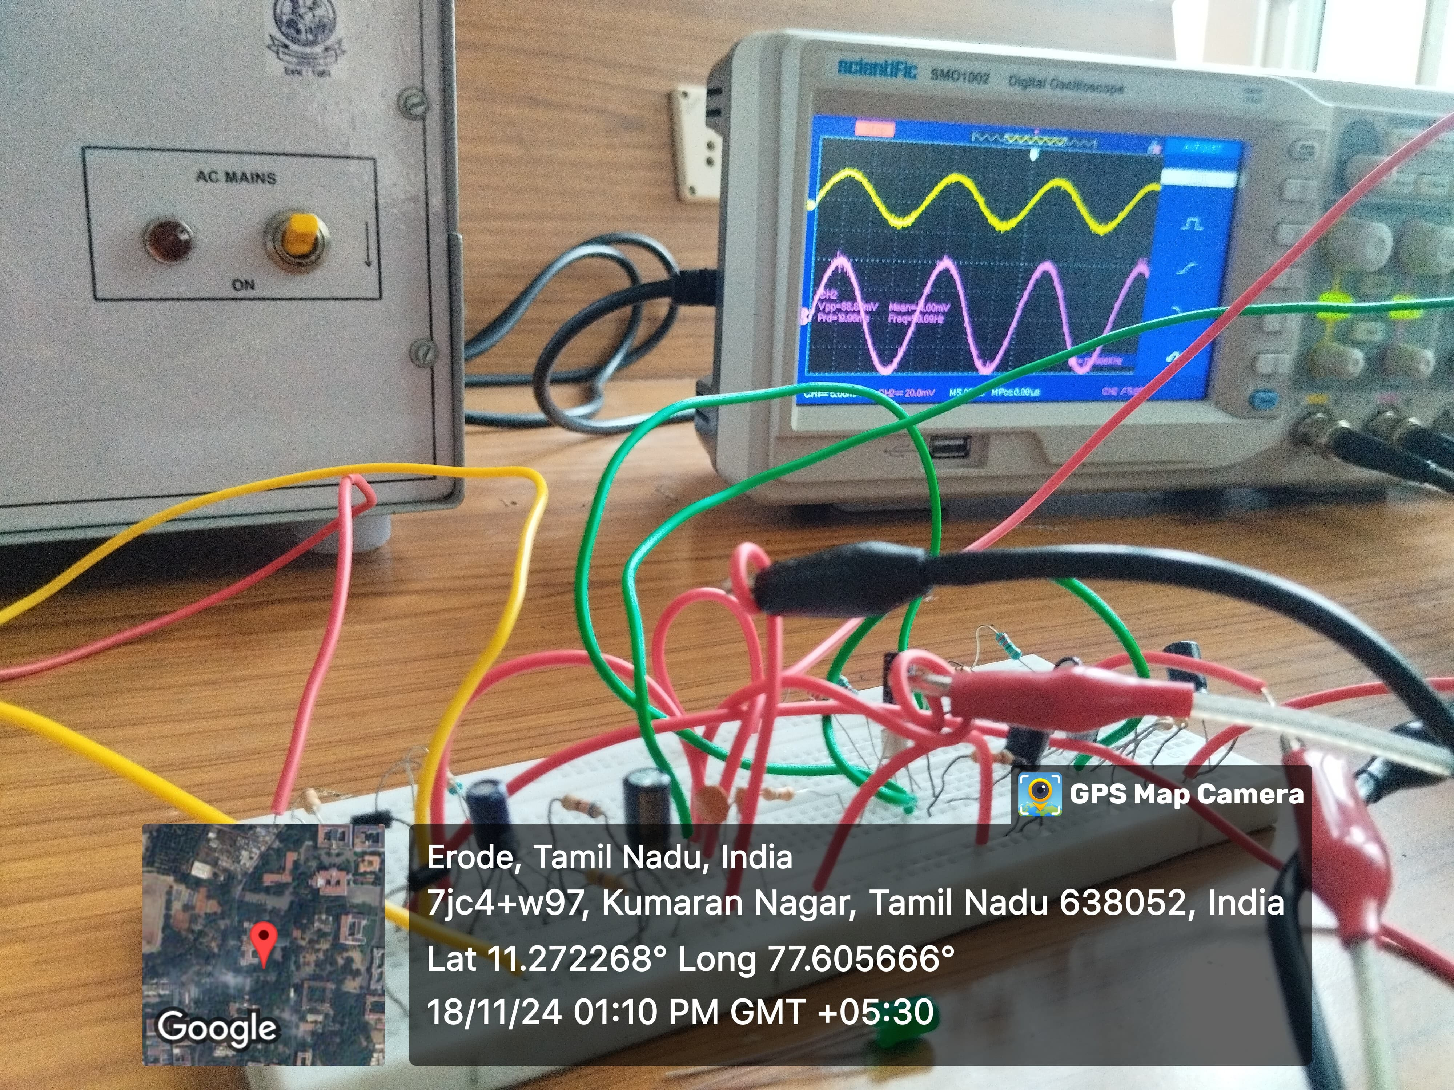
The Colpitts oscillator successfully generated a stable sinusoidal output, demonstrating reliable performance. The circuit sustained oscillations with consistent amplitude and minimal distortion, indicating effective feedback and amplification. The capacitive voltage divider provided regenerative feedback, while the current shunt feedback amplifier ensured adequate gain and stability.

The design aligned well with theoretical expectations, confirming the oscillator’s capability to maintain steady oscillations. Minor variations in performance could be attributed to non-ideal component characteristics but had minimal impact on functionality. Overall, the circuit proved to be an efficient solution for generating sinusoidal signals.

2.NAND GATE USING PN JUNCTION DIODE

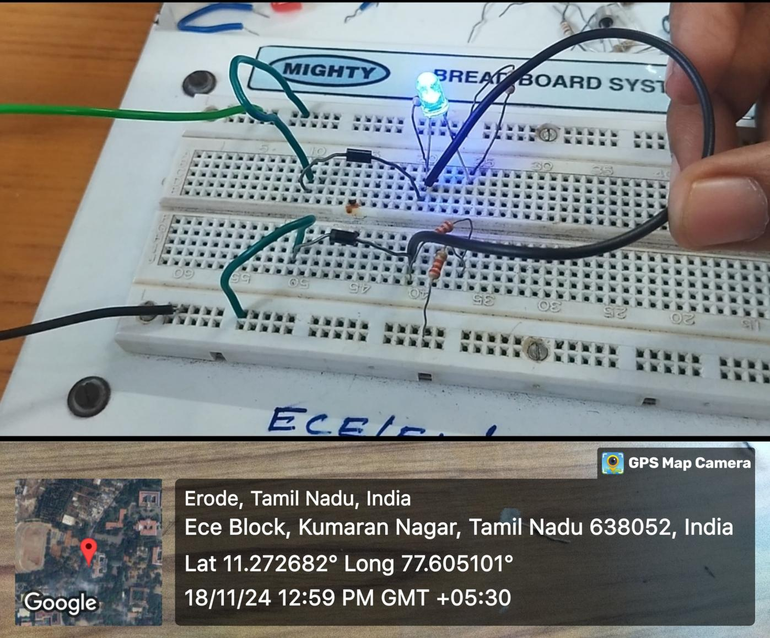
The NAND gate was successfully implemented using diodes and a resistor. The circuit produced a high output when at least one input was low and a low output only when all inputs were high, matching the NAND truth table. The transitions between logic states were clear and reliable.

The diodes acted as switches, controlling the flow of current based on the input states, while the resistor ensured proper voltage levels for logic high and low. The circuit's performance aligned well with theoretical expectations, validating its functionality.

Minor voltage drops due to diode forward characteristics were observed but had negligible impact on the operation. Overall, the design demonstrated an efficient and practical approach to implementing basic logic gates using discrete components.

CONCLUSION
1.COLPITTS OCILLATOR WITH CURRENT SHUNT FEEDBACK AMPLIFIER

The Colpitts oscillator with a current shunt feedback amplifier successfully achieves stable sinusoidal wave generation and amplification, meeting the requirements of frequency accuracy, signal stability, and amplification efficiency. The oscillator’s capacitive divider configuration ensures precise frequency control, while the feedback amplifier enhances the signal with consistent gain, reduced distortion, and improved linearity. Together, these circuits deliver a robust and reliable system suitable for various applications.
The Colpitts oscillator’s simplicity and reliability make it ideal for generating clean sinusoidal signals, while the current shunt feedback amplifier ensures effective amplification with noise reduction and gain stability. Negative feedback in the amplifier improves performance and minimizes signal variations, making the design adaptable to diverse environments and conditions.
This project combined theoretical design with practical implementation through simulation, prototyping, and testing. Simulations validated the design, while real-world testing ensured the circuit’s performance met expectations. The final design demonstrated stability, reliability, and versatility, confirming its suitability for applications in signal processing, communication systems, and electronic testing.
In conclusion, this project showcases the effective integration of oscillator and amplifier technologies, providing a reliable solution for sinusoidal wave generation and amplification. Its modular design and adaptability make it a valuable asset for future advancements in analog circuit design and related fields.

- NAND GATE USING PN JUNCTION DIODE
The implementation of a NAND gate using PN junction diodes demonstrates the fundamental principles of digital logic design by utilizing basic semiconductor components. This project highlights the versatility of diodes in constructing logic gates, showcasing their ability to process binary signals effectively. By integrating PN junction diodes with resistors and a power supply, the design achieves the functionality of a NAND gate, which is a universal gate capable of forming any other logic gate.
The design leverages the diode's inherent properties, such as its ability to allow current flow in one direction and block it in the reverse direction, to create the desired logic output. When both inputs are high, the diodes conduct, resulting in a low output, while for all other input combinations, the output remains high. This behavior aligns with the truth table of a NAND gate, validating the circuit's operation.
The simplicity and efficiency of this design underline the practical application of basic electronic components in creating complex digital circuits. This approach is particularly valuable in educational contexts, providing a hands-on understanding of how logic gates are constructed and how they function at the most basic level.
In conclusion, the realization of a NAND gate using PN junction diodes demonstrates a successful fusion of theoretical principles and practical implementation. It serves as an excellent foundation for understanding digital logic circuits and exploring more advanced designs. This project underscores the importance of diodes in digital electronics and their potential for further applications in integrated circuit design and digital systems.

